Common Problem and Solution
Q: How to install the car radio?
A: Please see the video as a reference:https://bit.ly/2yMe0bZ
Q: Why my steering wheel control cannot work?
A: please set the can type to 195 then the steering wheel control will be work.please go to Setup, scroll down to about device, click factory settings at top. Put in password 5839, then select CAN Type.Try the 195 option. Turn off the ignition for a min and back on. it will be ok.
Q: The bluetooth of the cell phone cannot connect with the car radio?
A: Please do as below:
1)Turn on the usb debug(you need enable the developer option in your cell phone first.if you didnot know where is the developer option of your cell phone,you can google it).
2)Using a usb cable to connect the stereo and your cell phone.
3)Scan the code and download a moblie app and then install it.
4)After install the app then it will be ok.
Q: The Bluetooth won’t reconnect on its own when restart the car?
A: 1)Please go into “setup”->“bluetooth”-> “auto connect” and slide it to “Y”.
2)please change another cell phone to have a try.
Q: How to customize the wallpaper?
A:Be sure the format of the photo is JPG,and the resolution of the photo is 800*480 or 1000*480.(when you use the sd card we advise you use the slot of RST)
Q: How to change boot logo?
A: Please go into setting -->Boot Logo(the code is:3506)
Q: Can it play video while driving?
A:Yes,go into setup to “VIDEO”. That bring screen up “Watching video is forbidden while driving” and you can slide the switch to yes.
Q: Where to mount the gps module?
A: Please put it to the A column of the car.

Q: Can i add my rear camera to the car radio?
A: Yes,you can have a try,if your rear camera is not working with the car radio,then you can buy one from us.
Q: How to connect the rear camera?
A: You plug into “camera in” and “red wire“ goes to “pink wire“.please see the photo below.
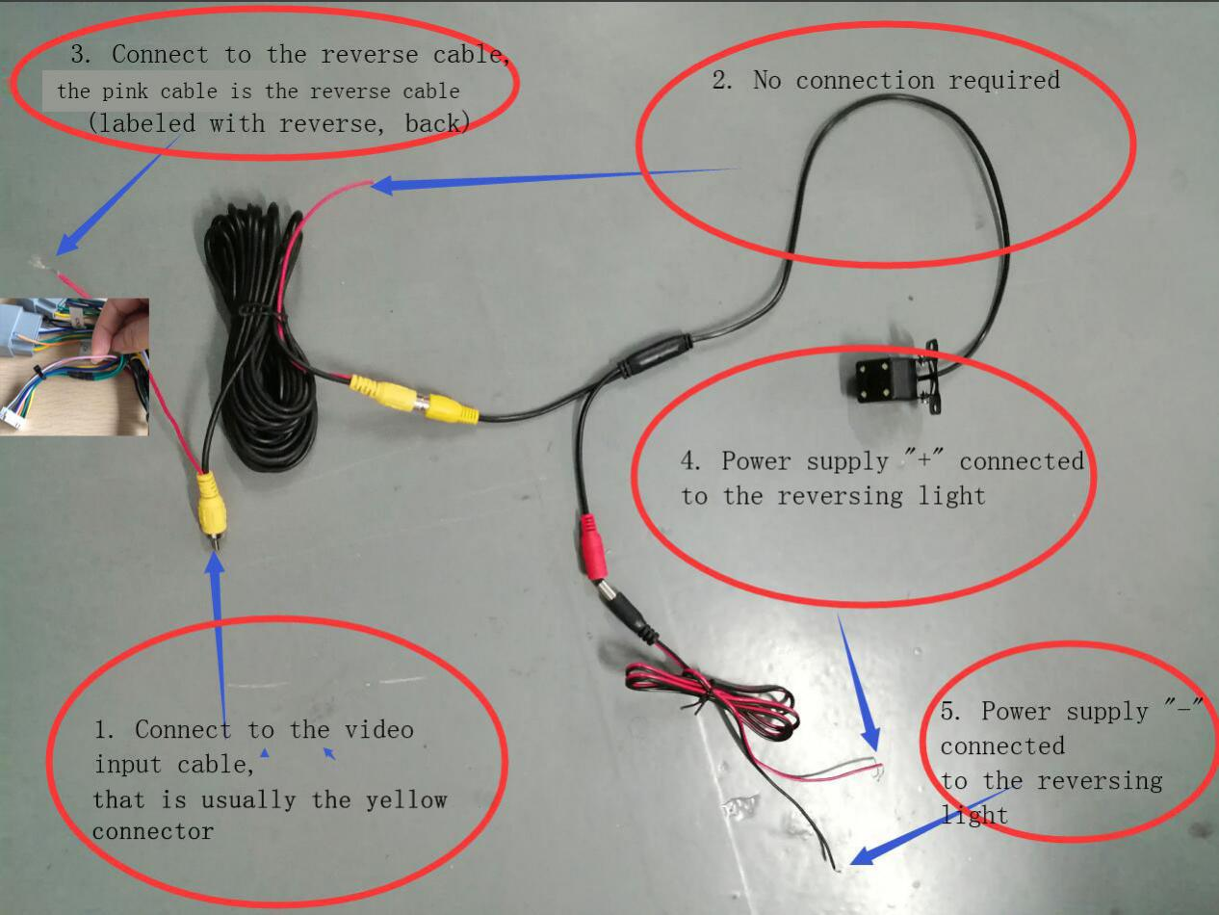
Q: How to set the time?
A: Please go into “date and time” and go into time zone setting and choose the correct time zone,it will be ok.

If you have any questions please feel free to contact us via awesafe-us.ca@outlook.com
https://www.awesafe.cn/

